| **Ex No:**  **Date: 11-09-24** | **Denoising using a Convolutional Neural Network (CNN) Autoencoder** |
| --- | --- |

**Objective:**

The goal of this experiment is to train a CNN Autoencoder to denoise images from the Fashion MNIST dataset. The model will learn to reconstruct clean images from noisy versions of the same data.

**Descriptions:**

1. Dataset Preparation: The Fashion MNIST dataset is used, but with a modification — random noise is introduced to the images. These noisy images are used as input to the model, and the target is to reconstruct the original, clean images.

2. Autoencoder Model: A CNN Autoencoder architecture is employed, which is designed to learn efficient codings for noisy inputs by compressing the input data into a lower-dimensional representation and then reconstructing it.

3. Training and Evaluation: The model is trained on noisy data with the objective of minimizing the difference between the reconstructed (output) and original clean images.

**Model:**

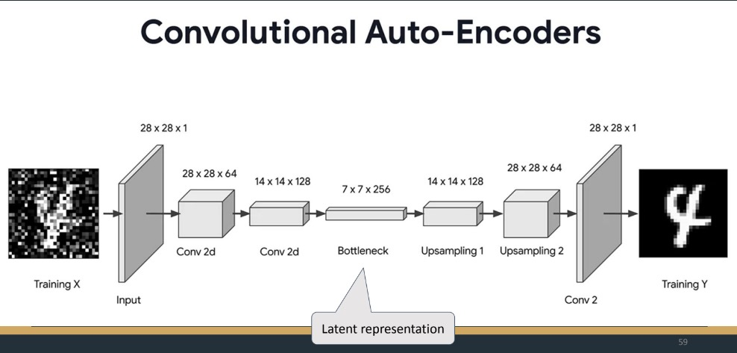

The architecture being used is a CNN Autoencoder, which typically consists of:

- Encoder: This compresses the input image into a lower-dimensional representation.

- Decoder: This reconstructs the image back to its original dimensions from the compressed representation.

**Building the Algorithm:**

1. Data Processing:

- Introduce noise to the dataset images.

- Normalize the noisy images.

2. Model Construction:

- Construct the CNN Autoencoder with convolutional layers for both encoding and decoding.

3. Training:

- Train the model using noisy images as input and clean images as the target.

4. Evaluation:

- Evaluate the model's performance by comparing the output (denoised images) with the original clean images.

**Output:**

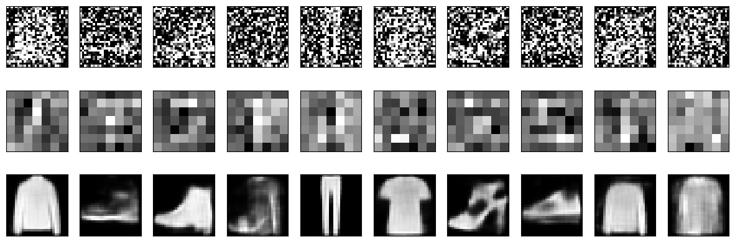

**GitHubLink:** [**https://github.com/chandanab1/Deep_Learning**](https://github.com/chandanab1/Deep_Learning)